## **📊 Key KPIs for Pizza Sales Analysis (with SQL Queries)**

### **1. 🧾 Total Revenue**

**Definition:** Total money earned from all orders  
 **Formula:** SUM(total_price)

SELECT

round(SUM(total_price),2) AS total_revenue

FROM pizza_sales;



### **2. 💰 Average Order Value (AOV)**

**Definition:** Average revenue generated per order  
 **Formula:** SUM(total_price) / COUNT(DISTINCT order_id)

SELECT

ROUND(SUM(total_price) * 1.0 / COUNT(DISTINCT order_id), 2) AS avg_order_value

FROM pizza_sales;



### **3. 🍕 Total Pizzas Sold**

**Definition:** Total number of pizza units sold  
 **Formula:** SUM(quantity)

SELECT

SUM(quantity) AS total_pizzas_sold

FROM pizza_sales;



### **4. 🏆 Best-Selling Pizzas(Top 5)**

**Definition:** Pizzas with the highest quantity sold  
 **Formula:** SUM(quantity) grouped by pizza_name

SELECT TOP 5

pizza_name,

SUM(quantity) AS total_sold

FROM pizza_sales

GROUP BY pizza_name

ORDER BY total_sold DESC;

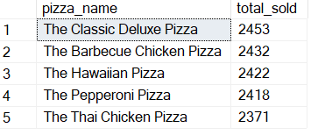

### **❌ Worst-Selling Pizzas(Bottom 5)**

**Definition:** Pizzas with the lowest quantity sold

SELECT TOP 5

pizza_name,

SUM(quantity) AS total_sold

FROM pizza_sales

GROUP BY pizza_name

ORDER BY total_sold ASC;

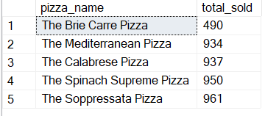

### **6. ⏰ Peak Order Hour(TOP 5) (By Revenue)**

**Definition:** The hour of the day when most sales occur  
 **Formula:** Group by HOUR(order_time)

SELECT TOP 5

DATEPART(HOUR, order_time) AS order_hour,

round(SUM(total_price),2) AS hourly_revenue

FROM pizza_sales

GROUP BY DATEPART(HOUR, order_time)

ORDER BY hourly_revenue DESC;

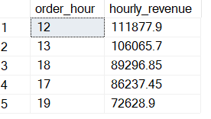

### **7. 📅 Highest Grossing Day of the Week**

**Definition:** A Day with the highest total revenue  
 **Formula:** Group by weekday name

SELECT

DATENAME(WEEKDAY, CAST(order_date AS DATE)) AS day_name,

round(SUM(total_price),2) AS daily_revenue

FROM pizza_sales

GROUP BY DATENAME(WEEKDAY, CAST(order_date AS DATE))

ORDER BY daily_revenue DESC;

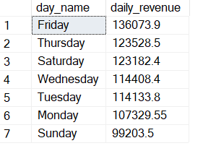

### **8. 📐 Revenue by Pizza Size**

**Definition:** Total revenue earned by each pizza size

SELECT

pizza_size,

round(SUM(total_price),2) AS revenue

FROM pizza_sales

GROUP BY pizza_size

ORDER BY revenue DESC;

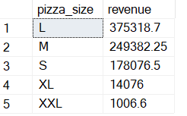

### **9. 🥦 Revenue by Pizza Category**

**Definition:** Revenue earned by Classic, Veggie, Supreme, and Chicken

SELECT

pizza_category,

SUM(total_price) AS revenue

FROM pizza_sales

GROUP BY pizza_category

ORDER BY revenue DESC;

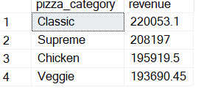

### **10. 🪑 Estimated Seat Utilisation Rate**

**Customer Estimation Logic**

We analysed 21,350 unique orders and 48,620 pizza line items. On average, each order consists of 2.28 pizza items.

Therefore, we estimate customer count based on the number of order_details_id, assuming each pizza item represents one person (≈ 1 pizza per person).

This results in an estimated **48,620 customers** served over the year.

SELECT

ROUND(CAST(48620 AS FLOAT)/60, 2) AS total_full_seat_cycles,

ROUND(CAST(48620 AS FLOAT) / 60 / 365, 2) AS avg_full_seat_cycles_per_day,

ROUND(CAST(48620 AS FLOAT) / (365 * 60) * 100, 2) AS avg_daily_seat_utilization_percent



**Seating Utilisation Insight:**

Over the years, Plato’s Pizza served approximately 48,620 customers.

Given 60 seats and 365 days, this equates to a **daily average seating utilisation of 222%**, meaning each seat is **used 2.2 times daily**.

This reflects a **healthy table turnover**, especially during peak hours.

Initially, we used order_details_id as a proxy for customer count, assuming each unique pizza configuration was intended for a separate person.

However, for more accurate **seating capacity analysis**, we use SUM(quantity) to represent estimated customers, under the assumption that **1 pizza ≈ 1 customer**. This provides a closer match to real-world dine-in behavior and accounts for actual volume of items served.

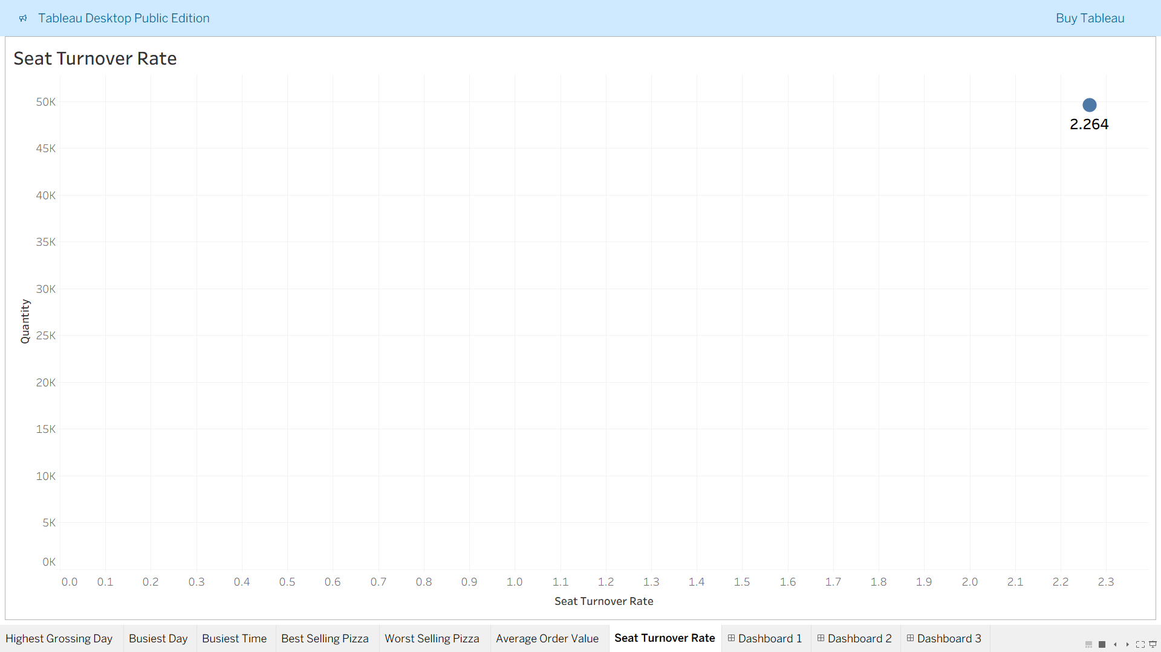

This makes Seat Turnover Rate **2.264** times per day.

Note:- We can make the assumption that 1 table is occupied by 4 seats.

**11. Busiest Day of the Year**

As seen in Tableau Chart Busiest Day is **Friday**

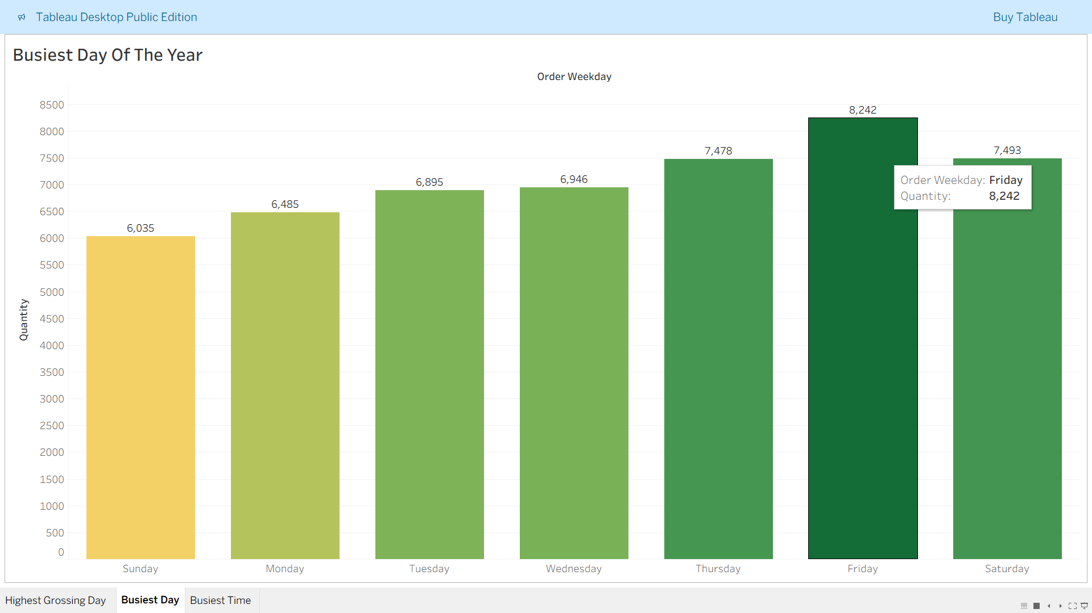

During this day, the highest of 8242 pizzas are made in a year.

**12. Busiest Time of the Year**

As seen in Tableau Chart Busiest Time is 12:00 PM.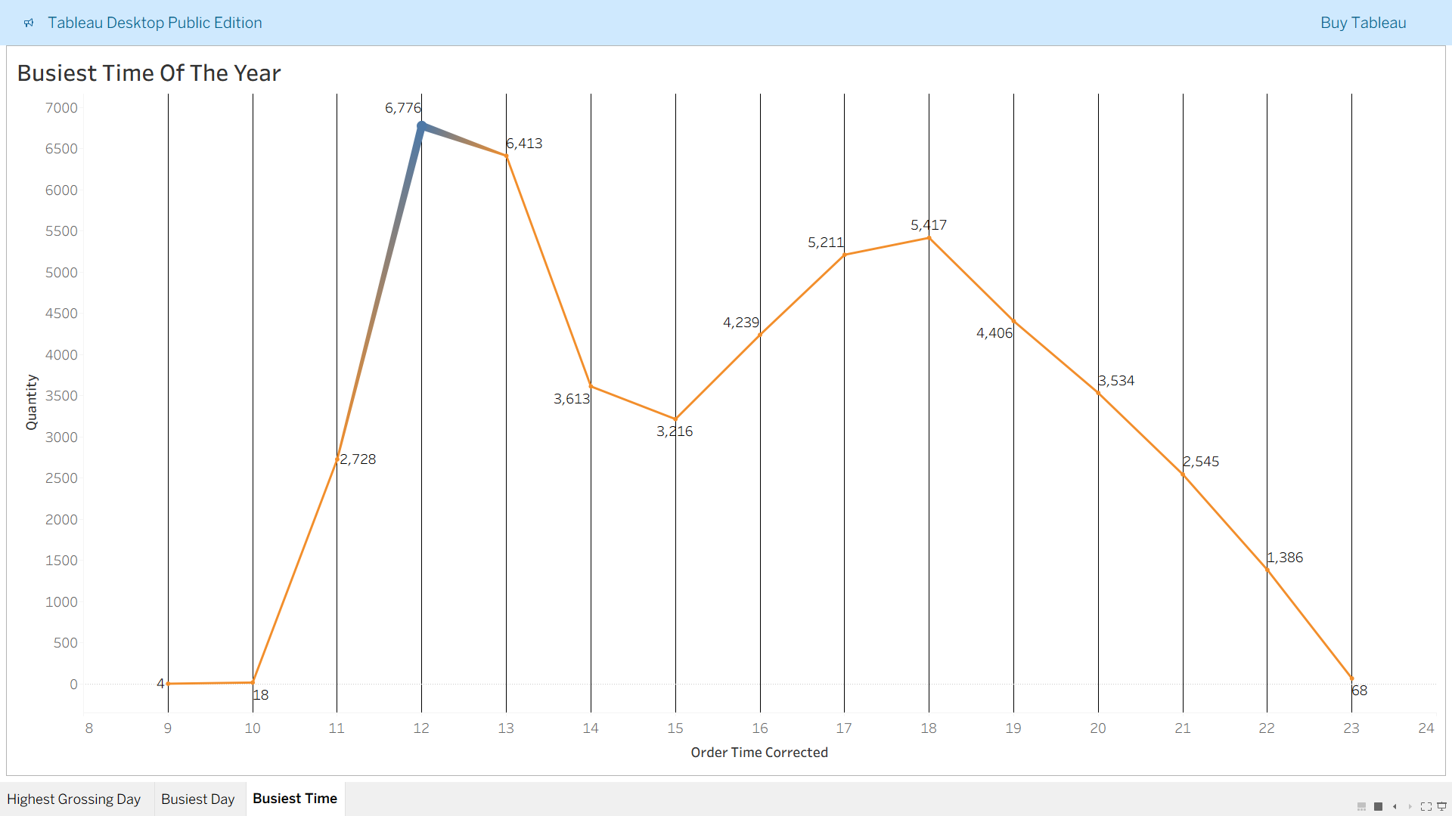

During this time, the highest of 6776 pizzas are made in a year.

**Pizzas made at 12 PM on Fridays only, using SQL**

SELECT SUM(quantity) AS pizzas_at_noon_on_friday

FROM pizza_data.dbo.pizza_sales

WHERE DATEPART(HOUR, order_time) = 12

AND DATENAME(WEEKDAY, order_date) = 'Friday';

